**Asset Management**

Database :

Create database digital_asset;

Schema Design: 1. employees table:

create table employees( employees_id integer(10),

constraint employees_employees_id_pk primary key(employees_id),

name varchar(20),

department varchar(20),

email varchar(20),

password varchar(20));

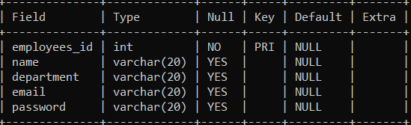

2. assets table:

create table assets(asset_id integer(10),

constraint assets_assest_id_pk primary key(asset_id),

name varchar(20),

type varchar(20),

serial_number integer(20) UNIQUE,

purchase_date Date,

location varchar(20),

status varchar(20),

owner_id integer(20),

constraint assets_owner_id_fk foreign key(owner_id) references employees(employees_id));

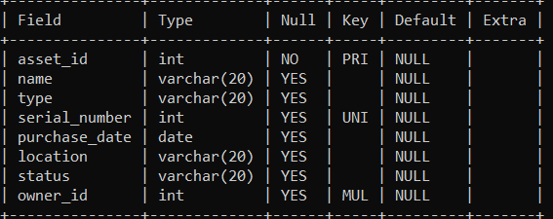

3. maintenance_records table:

create table maintenance_records(maintenance_id integer(10),

constraint maintenance_records_maintenance_id_pk primary key(maintenance_id),

asset_id integer(20),

constraint maintenance_records_asset_id_fk foreign key(asset_id) references assets(asset_id),

maintenance_date Date,

description varchar(30),

cost decimal(30));

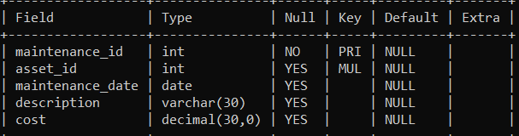

4. asset_allocations table:

create table asset_allocations(allocation_id integer(10),

constraint asset_allocations_allocation_id_pk primary key(allocation_id),

asset_id integer(10),

constraint asset_allocations_asset_id_fk foreign key(asset_id) references assets(asset_id),

employees_id integer(10),

constraint asset_allocations_employee_id_fk foreign key(employees_id) references employees(employees_id),

allocation_date Date,

return_date Date);

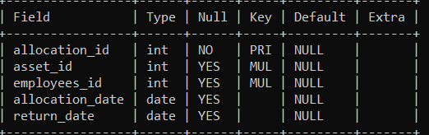

5. reservations table (to store order details):

create table reservations(reservation_id integer(10),

constraint reservations_reservation_id_pk primary key(reservation_id),

asset_id integer(20),

constraint reservations_asset_id_fk foreign key(asset_id) references

assets(asset_id),

employees_id integer(10),

constraint reservations_employees_id_fk foreign key(employees_id) references employees(employees_id),

reservation_date Date,

start_date Date,

end_date Date,

status varchar(30));

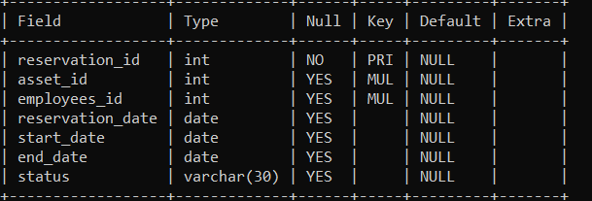

Employees:

INSERT INTO employees VALUES (101, ‘Matthew’, ‘Legal’, ‘matthew@gmail.com', ‘matt606');

INSERT INTO employees VALUES (102, 'Isabella', 'IT', 'isabella@gmail.com', 'isab707');

INSERT INTO employees VALUES (103, ‘David', ‘Finance’, ‘david@gmail.com’, ‘ ‘david789’);

INSERT INTO employees VALUES (104, 'Emily', 'Marketing', 'emily@gmail.com', 'emily101');

INSERT INTO employees VALUES (105, 'James', 'Operations', 'james@gmail.com', 'james202');

INSERT INTO employees VALUES (106, 'Olivia', 'Sales', 'olivia@gmail.com', 'oliv303');

INSERT INTO employees VALUES (107, 'Daniel', 'Research', 'daniel@gmail.com', 'daniel404');

INSERT INTO employees VALUES (108, 'Sophia', 'Finance’, 'sophia@gmail.com', 'sophia505');

INSERT INTO employees VALUES (109, 'Michael', 'Sales', ‘michael@gmail.com', 'michael12');

INSERT INTO employees VALUES (110, 'Sarah', 'IT', 'sarah@gmail.com', 'sarah45');

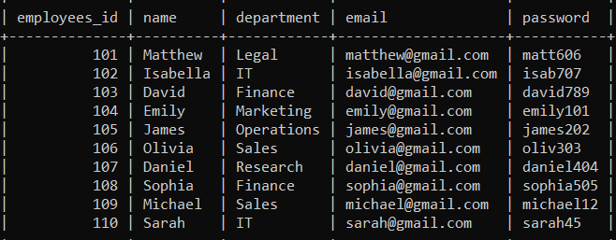

Assets:

INSERT INTO assets VALUES (1, 'Laptop', 'Electronics', 1001, '2023-01-10', 'Office', ' in use', 101);

INSERT INTO assets VALUES (2, 'Projector', 'Electronics’, 1002, '2020-02-15', 'Conference Room', ' decommissioned ', 108);

INSERT INTO assets VALUES (3, ' Desk', 'Furniture', 1003, '2019-05-20', 'Office', 'decommissioned', 103);

INSERT INTO assets VALUES (4, 'Chair', 'Furniture', 1004, '2022-06-18', 'Office', 'in use', 101);

INSERT INTO assets VALUES (5, 'HP Server', 'Server', 1005, '2024-03-25', 'Data Center', 'in use', 105);

INSERT INTO assets VALUES (6, ' Printer', 'Electronics', 1006, '2023-04-12', 'Office', 'under maintenance', 109);

INSERT INTO assets VALUES (7, 'Smartboard', 'Equipment', 1007, '2020-01-22', 'Meeting Room', ' under maintenance ',107);

INSERT INTO assets VALUES (8, 'Router', ' Equipment ', 1008, '2022-11-10', 'Data Center', 'in use', 110);

INSERT INTO assets VALUES (9, ‘Software License’, 'Software', 1009, '2021-02-05', 'Devices', ' decommissioned ', 103);

INSERT INTO assets VALUES (10, 'Antivirus', 'Software', 1010, '2022-03-15', 'Devices', 'under maintenance', 104);

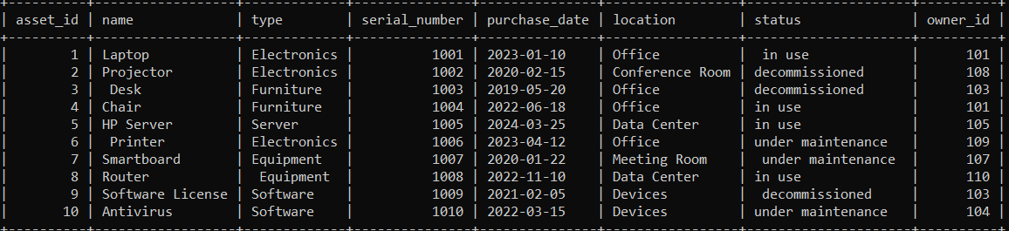

Maintenance records:

INSERT INTO maintenance_records VALUES (1011, 1, '2022-01-12', 'Battery Replacement', 5000.00);

INSERT INTO maintenance_records VALUES (1012, 6, '2023-04-18', 'Printer Maintenance', 1000.00);

INSERT INTO maintenance_records VALUES (1013, 3, '2019-04-05', 'Desk Repair', 200.00);

INSERT INTO maintenance_records VALUES (1014, 4, '2023-04-10', 'Chair repair', 120.00);

INSERT INTO maintenance_records VALUES (1015, 7, '2023-03-28', 'Cleaning', 500.00);

INSERT INTO maintenance_records VALUES (1016, 1, '2023-04-15', 'Battery Replacement', 5000.00);

INSERT INTO maintenance_records VALUES (1017, 5, '2023-01-25', 'Server Upgrade', 30000.00);

INSERT INTO maintenance_records VALUES (1018, 10, '2023-02-22', 'Software Update', 450.00);

INSERT INTO maintenance_records VALUES (1019, 9, '2023-03-30', 'Software Update', 900.00);

INSERT INTO maintenance_records VALUES (1020, 10, '2023-04-12', 'Software Update' , 200.00);

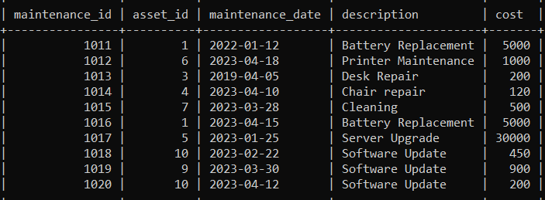

Asset allocations:

INSERT INTO asset_allocations VALUES (1021, 3, 101, '2023-01-15', NULL);

INSERT INTO asset_allocations VALUES (1022, 6, 103, '2023-04-20', '2023-03-01');

INSERT INTO asset_allocations VALUES (1023, 1, 108, '2023-03-05', '2024-06-01');

INSERT INTO asset_allocations VALUES (1024, 2, 103, '2023-04-10', NULL);

INSERT INTO asset_allocations VALUES (1025, 5, 106, '2024-03-28', '2024-12-15');

INSERT INTO asset_allocations VALUES (1026, 1, 107, '2024-04-20', '2024-09-01');

INSERT INTO asset_allocations VALUES (1027, 7, 105, '2023-01-25', '2023-02-15');

INSERT INTO asset_allocations VALUES (1028, 4, 108, '2024-02-22', NULL);

INSERT INTO asset_allocations VALUES (1029, 9, 109, '2022-03-30', '2023-04-05');

INSERT INTO asset_allocations VALUES (1030, 10,110, '2024-04-12', NULL);

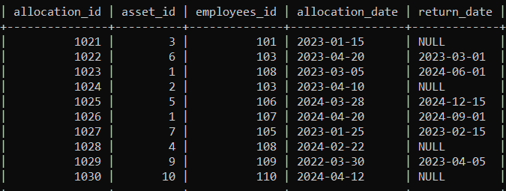

Reservations :

insert into reservations values(20001,2,101,'2024-01-01','2024-01-05','2024-03-25','pending');

insert into reservations values(20002,3,103,'2024-02-04','2024-02-25','2024-04-25','approved');

insert into reservations values(20003,5,108,'2023-11-30','2023-12-05','2023-12-29','canceled’);

insert into reservations values(20004,1,110,'2023-12-01','2024-12-15','2024-04-25','pending');

insert into reservations values(20005,9,109,'2024-01-21','2024-01-27','2024-05-23','approved');

insert into reservations values(20006,6,102,'2024-02-28','2024-02-29','2024-06-01','pending');

insert into reservations values(20007,4,105,'2024-03-01','2024-04-16','2024-04-30','canceled');

insert into reservations values(20008,7,107,'2023-12-17','2024-12-19','2024-02-29',' approved ');

insert into reservations values(20009,10,104,'2024-01-31','2024-03-05','2024-04-18',' canceled ');

insert into reservations values(20010,8,106,'2024-01-01','2024-05-05','2024-07-18',' approved ');

